Presented To

**3MTT hackathon 2025**

**Presented By Trinova Team Kano**

hello@samanthagreenfield.com

+123-456-7890

November 20, 2025

**Project Title: Agricultural Productivity Enhancement App (APE App)**

**Thematic Area: Agriculture & Food Security**

**Problem Statement**

**Trinova**

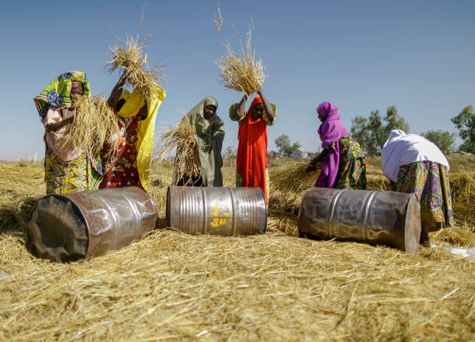

**Problem Statement**

Small-scale farmers in Kano face significant challenges in accessing modern agricultural knowledge, tools, and resources to increase crop productivity. Factors like climate variability, pest outbreaks, and limited knowledge of sustainable farming techniques reduce yield and increase vulnerability to crop loss, impacting food security and income levels in rural areas.

Video Link: <https://drive.google.com/file/d/1CkS92fHDaM6sjiqUWB5CJKVW3PVzfJJz/view?usp=drive_link>

**Project Objectives**

1. **Provide Real-time Farming Information**: Supply farmers with region-specific advice on planting, crop management, and harvesting.
2. **Improve Disease and Pest Management**: Offer accessible guidance for diagnosing and managing crop diseases and pest infestations.
3. **Deliver Weather Forecasts**: Provide timely weather updates to assist farmers in planning field activities and avoiding adverse weather impacts.
4. **Promote Sustainable Practices**: Educate farmers on sustainable agricultural practices to boost yield and conserve resources.

**Target Audience**

The app primarily targets small-scale farmers in Kano’s rural communities who have access to smartphones or feature phones.

**Project Scope**

1. **App Development**: Design and develop an Android application that is simple, intuitive, and optimized for low-data usage.
2. **Content Creation**: Develop a knowledge base with information on farming best practices, pest and disease control, and sustainable techniques, tailored to common crops in Kano.
3. **Weather API Integration**: Integrate a reliable weather API to provide real-time weather information for precise local conditions.
4. **Interactive Support**: Enable a chat feature or voice-enabled bot for farmers to ask specific questions about crop diseases or pest control.
5. **Data Collection**: Gather data on app usage, crops grown, and common pest issues to refine content and provide valuable insights for local agricultural extension services.

**Project Phases**

1. **Phase 1: Research and Needs Assessment**

* Conduct surveys and interviews with local farmers to gather insights on challenges, information gaps, and app feature preferences.
* Collaborate with agricultural extension officers and local experts to ensure content relevance and accessibility.
* Analyze the most commonly grown crops, soil types, and pest issues in Kano to create tailored content.

1. **Phase 2: App Design and Development**

* **User Interface (UI)**: Design an easy-to-navigate interface suitable for rural users, incorporating visual guides for users with limited literacy.
* **Core Features**:
  + - **Weather Forecasting**: Daily and weekly updates, alerts for extreme weather.
    - **Farming Practices**: Step-by-step guides for crop planting, growth, and harvesting.
    - **Disease & Pest Identification**: Visual aids and Q&A for identifying crop issues.
    - **Soil Health Management**: Tips on soil preparation, nutrient management, and erosion control.
* **Language Localization**: Translate content into Hausa for accessibility.

1. **Phase 3: Content Development and Verification**
   * Collaborate with agronomists to create accurate, region-specific farming advice.
   * Create multimedia content (videos, audio guides) for illiterate users.
   * Review and validate all content with local agricultural experts to ensure relevance.
2. **Phase 4: Testing and Pilot Program**
   * Select a sample group of farmers in Kano for a pilot test, collect feedback, and assess usability.
   * Adjust features and content based on farmer feedback to enhance user-friendliness.
   * Ensure compatibility on different smartphone types and with low-speed internet.
3. **Phase 5: Deployment and Training**
   * Launch the app on the Google Play Store and distribute through local channels and farmer cooperatives.
   * Organize training sessions to introduce farmers to the app and its benefits.
   * Provide ongoing support through local agricultural extension agents.
4. **Phase 6: Monitoring and Evaluation**
   * Monitor app usage, gather feedback, and track metrics such as active users, common queries, and crop yield improvements.
   * Conduct regular updates to address emerging issues, seasonal crops, and new pest or disease information.
   * Develop a feedback loop with farmers and local organizations for continuous improvement.

**Technology Stack**

* **Platform**: Android
* **Weather Forecast**: Weather API (e.g., OpenWeatherMap, Climacell)
* **Programming Languages**: Java/Kotlin (Android), Python (backend, if applicable)
* **Database**: Firebase or a lightweight local database for offline content
* **Design Software**: Figma or Adobe XD for UI/UX

**Impact and Benefits**

1. **Increased Crop Yields**: With access to improved farming techniques, farmers can increase their productivity.
2. **Reduced Losses from Pests and Weather**: Real-time updates on pest control and weather forecasting help reduce losses.
3. **Empowerment Through Knowledge**: Farmers become better decision-makers with access to valuable agricultural knowledge.
4. **Boosted Local Economy**: Higher yields can contribute to economic growth, reducing food insecurity in Kano.

**Evaluation Metrics**

1. **App Usage**: Track the number of active users and engagement metrics.
2. **Farmer Feedback**: Collect and analyze farmer satisfaction, app usability, and reported yield improvements.
3. **Impact on Yields**: Evaluate crop productivity among app users versus non-users.
4. **Pest/Disease Management Success**: Track reported pest/disease outbreaks and farmers' responses.

**Potential Challenges and Mitigation**

* **Challenge**: Limited smartphone ownership in rural areas.
* **Mitigation**: Consider compatibility with feature phones or USSD services.
* **Challenge**: Low literacy levels among some farmers.
  + **Mitigation**: Use audio guides, videos, and icon-based navigation to simplify the app.
* **Challenge**: Sustainable funding for maintenance.
  + **Mitigation**: Seek partnerships with NGOs, government programs, and agribusinesses interested in supporting the project.

**Conclusion**

The **Agricultural Productivity Enhancement App** will empower small-scale farmers in Kano to adopt modern farming practices, improving crop yields, increasing income, and supporting food security in the region. By offering real-time insights, weather forecasting, and tailored farming advice, this app addresses critical needs while aligning with the NTDA’s evaluation criteria, creating a scalable, impactful solution for agricultural challenges in Kano and beyond.

**Image of the app:**

